Clyde Hamilton SN:16029077 (Line Chief) of the 76th Service Squadron.
Attached to the 386th Bomb Group.
Born in Roscoe, Pennsylvania on January 22nd, 1921. He enlisted in the Autumn of 1941, because America was not yet at war he needed at least two recommendations before he would be accepted. He got one from his part-time employer and another from the president of a bank. Jobs were scarce, the peace time army small, and there was competition for enlistments. How soon things were about to change...
Clyde served at Boxted and at Dunmow and moved with the group when they left for France.
A Line Chief was in charge of major repairs on the Marauders. This selection of photos shows some of these operations.

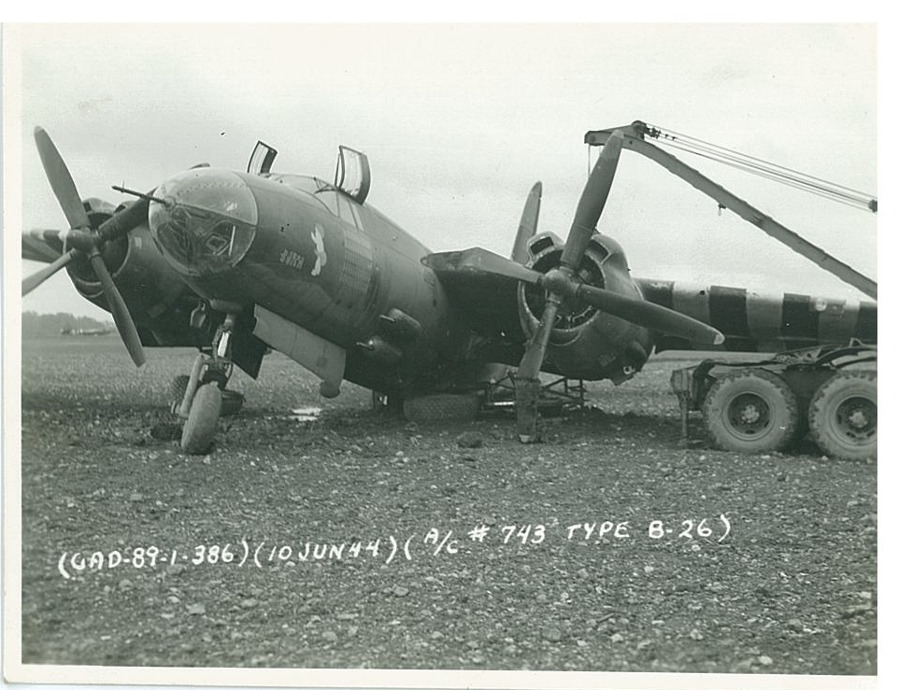
Marauder with collapsed undercarriage being lifted by a lorry crane.

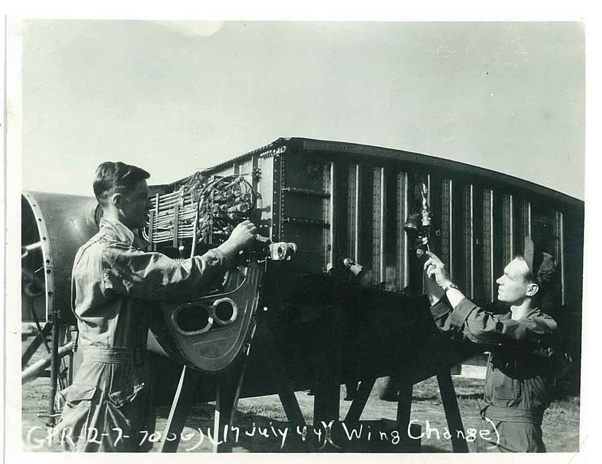
Marauder undergoing a complete wing change.

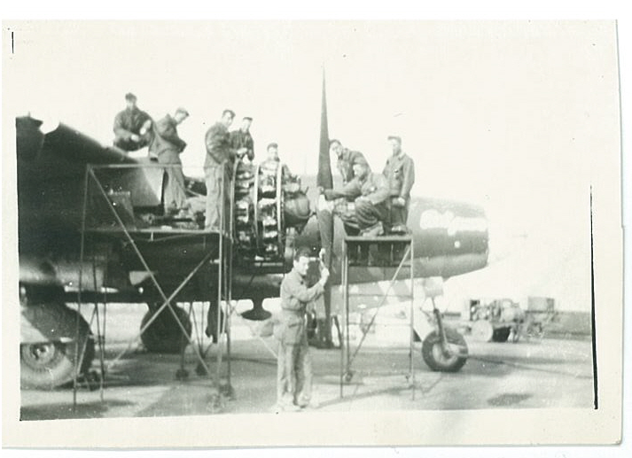

A major repair

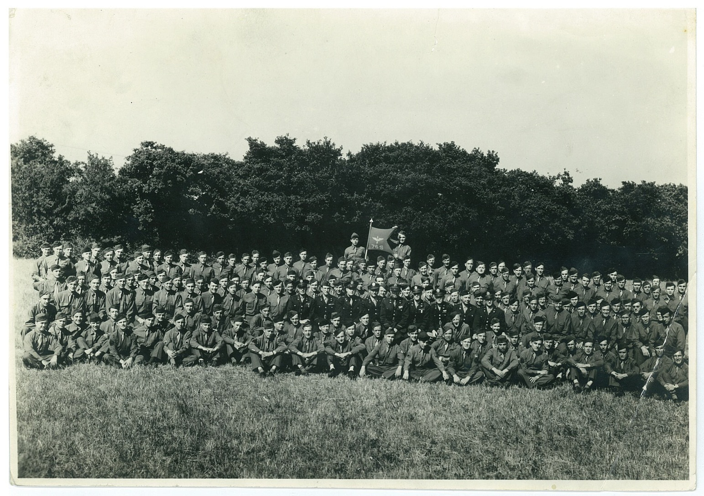
76th Service Squadron

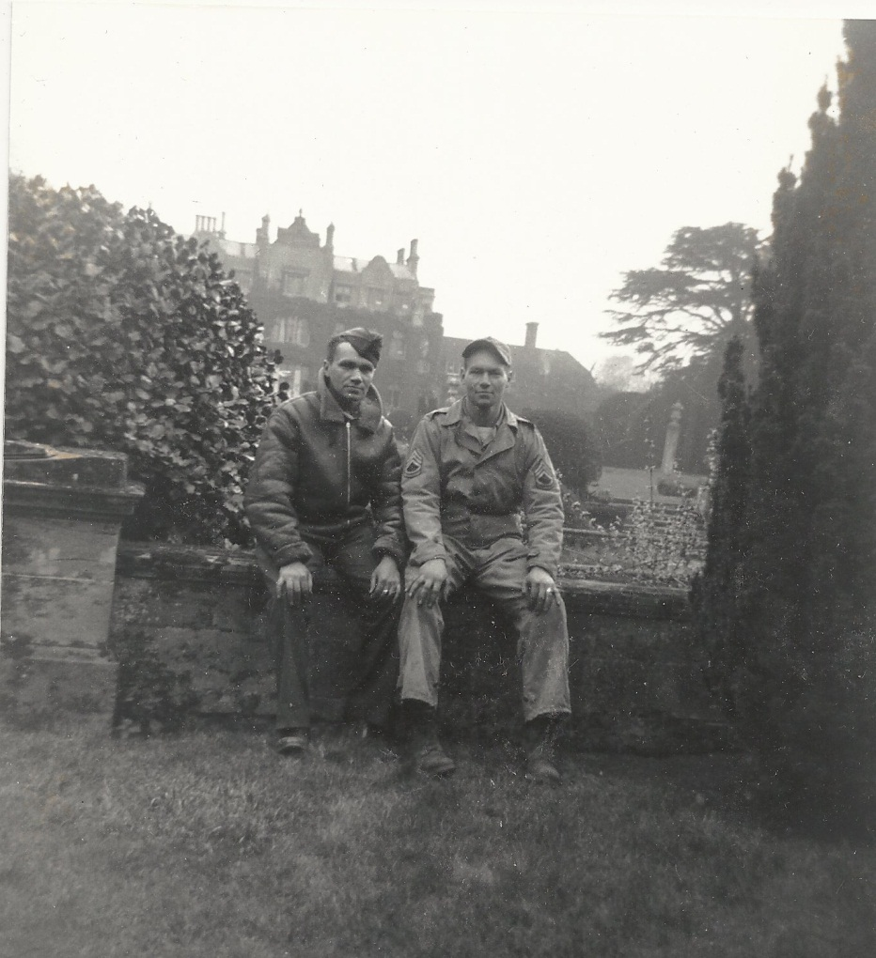
Clyde (on right) with his brother James at Dunmow.
Shortly after James told Clyde “He would not survive the war and to look after mum and dad” James was killed during the Normandy break out.

